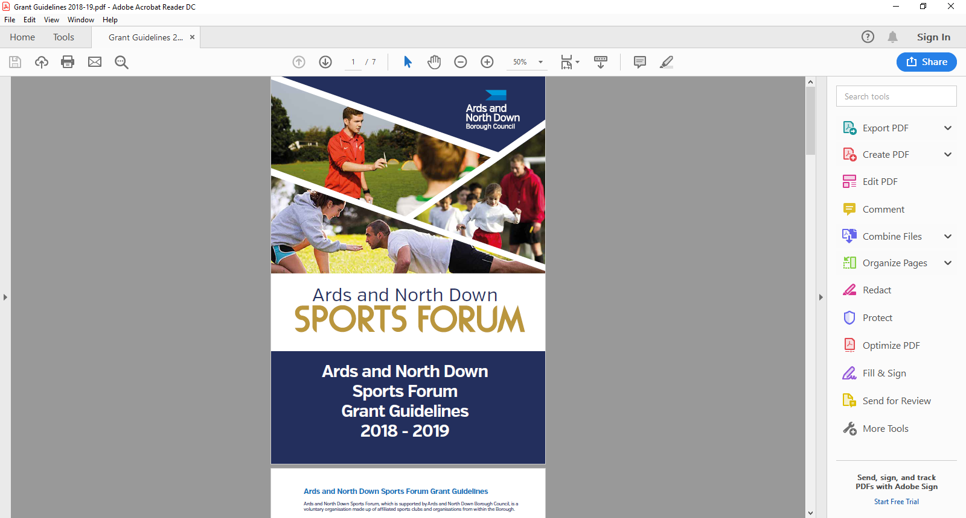

2025-2026

Events

Application Form

**Application Timeline**

Event grants will be open in 2 tranches. Please refer to event guidelines before completing

the application form. <https://www.leisureardsandnorthdown.com/sports-development/funding>

|  |  |
| --- | --- |
| **Tranche 1** | **£5,000** |
| **OPEN** Monday 19th May at 12noon and **CLOSE** at 12noon on Tuesday 17th June 2025 | |
| Assessment will be week commencing Monday 23th June 2025 | |
| Notification to sports clubs will be week commencing Monday 30th June 2025 | |
| **Please note**: if there is any underspend in Tranche 1 funds will roll into Tranche 2. | |

|  |  |
| --- | --- |
| **Tranche 2** | **£5,000** |
| **OPEN** Monday 25th August at 12noon and **CLOSE** on 12noon Tuesday 23rd September 2025 | |
| Assessment will be week commencing Monday 29th September 2025 | |
| Notification to sports clubs will be Monday 6th October 2025 | |
| **Please note**:  Following grant assessment and allocations and if there is funding remaining, Council may consider awarding grants of more than £1,500 should the need be identified and in merit order. | |

**Applicant Eligibility**

To be eligible to apply, applicants must meet the following eligibility requirements.

* Be affiliated to the Ards and North Down Sports Forum
* Event must be delivered within the Borough of Ards and North Down
* Have a Formal Constitution
* Have a Safeguarding Children and/or Vulnerable Adult Policy
* Have an Equality Policy
* Have adequate Public Liability Insurance
* Submit an Event Risk Assessment

**Funding Limits**

The maximum funding per sporting organisation for an Event Grant is £1,500 (per financial year), subject to available funds. Max of £500 can be allocated to Fundamental equipment for your event.

Should the programme be oversubscribed and due to limited funds available, a reduction in funding percentage will be applied to pending applications at that time.

**ONLY APPLICATIONS COMPLETED IN A TYPED FORMAT CAN BE ACCEPTED.**

**Section 1 - Organisational Details**

|  |  |
| --- | --- |
| Name of Club/ Organisation |  |
| Sport |  |
| Governing Body |  |
| Contact Name |  |
| Role/Position within Club/ Organisation |  |
| Address for Correspondence |  |
| Contact telephone number |  |
| Contact Email address |  |
| Ards and North Down Sports Forum Reference Number 2025/26 |  |
|  |  |
|  |  |

**Section 2 – Event Details / Criteria**

|  |  |
| --- | --- |
| **Name of Event** |  |
| **Date of Event** |  |
| **Location of Event** |  |

Please demonstrate how your project addresses the criteria below.

**Please use SMART principles (Specific, Measurable, Achievable, Relevant, Time-framed) when answering the following questions.**

|  |  |
| --- | --- |
| **1.Please outline the following:**  **- Event details**  **- How your event will increase participation?**  (10marks) |  |
| **2. Please demonstrate the need for the event, how it will benefit the club and the local community.**  (15marks) |  |
| **3. Please provide approx. participation numbers for the event:**  **- Club members**  **- Volunteers**  **- visitors/ entries**  (25 marks) |  |
| **4. Please demonstrate how the event will improve and sustain activities within the club.**  **(**25marks) |  |
| **5. Does your event target any priority groups (women, disability, over 50’s and social disadvantaged areas/groups.**  (25marks) |  |

A quality scoring threshold of 50 will be applied. Any application that fails to meet the above threshold will not be considered for funding.

**Section 3 - Funding Details**

|  |  |  |  |  |
| --- | --- | --- | --- | --- |
| Project breakdown | Net Costs  (excluding VAT) | VAT Costs | Total project costs | Amount requested from funding |
|  | £ | £ | £ | £ |
|  | £ | £ | £ | £ |
|  | £ | £ | £ | £ |
|  | £ | £ | £ | £ |
|  | £ | £ | £ | £ |
| **Total Costs** | **£** | **£** | **£** | **£** |

|  |  |
| --- | --- |
| Where will the balance of funding come from if total costs cannot be funded? |  |

|  |  |  |
| --- | --- | --- |
| Is your club/organisation VAT registered? | Yes | No |
| If yes, what is your VAT registration number? |  | |
| Does your club / organisation intend to claim VAT back if successful? | Yes | No |

**Section 4 – Any additional information**

Please provide any additional information which you feel is relevant to your application.

|  |
| --- |
|  |

**Section 5 – Document Checklist**

**Please ensure the following documents are attached to your application**

|  |  |  |
| --- | --- | --- |
| **Documents Required** |  | **Attached** |
| Club/Organisation Constitution | **Essential** |  |
| Copy of Public Liability Insurance | **Essential** |  |
| Copy of Club/Organisation Equality Policy | **Essential** |  |
| Club/Organisation Safeguarding Children  and/or Vulnerable Adults Policy (must have been reviewed and signed & dated within the past 3 years) | **Essential** |  |
| If a Club is adopting the National Governing Body Safeguarding Policy, the Club must provide written confirmation of this, and provide details of Designated Safeguarding Officers. | **Essential** |  |
| Event Risk Assessment | **Essential** |  |
| Please confirm the following | **Please tick** |  |
| Does your organisation have an event management in place? | **Yes** | **NO** |

**For further information regarding event management please refer to the link below:**

[Event Management Toolkit - Ards and North Down Borough Council](https://www.ardsandnorthdown.gov.uk/business/event-management-toolkit)

**Incomplete applications, and applications received without the accompanying mandatory supporting documentation, will be deemed ineligible and not proceed for assessment.**

**Section 6 – Declaration**

|  |
| --- |
| I declare that the information provided is correct to the best of my knowledge.  I agree to promote equality and good relations in all our activities involving the use of Council funding in accordance with Section 75 of the Northern Ireland Act 1998.  I declare that I will complete a Grant Report Form after my event and will acknowledge the funders in all publicity.  I declare that the Council will be notified immediately of any additional findings not declared in this application.  It is understood that monies will only be paid out on the production of all, receipts.  Any grant funding deemed ineligible or not spent will be re-payable to Ards and North Down Borough Council. |
| This must be signed by the Chairperson of the organisation/club alongside another Club Member and dated accordingly.   |  |  |  | | --- | --- | --- | |  | **Chairperson** | **Club Member** (Position in Organisation) | | Signed |  |  | | Name  (Please print) |  |  | | Date |  |  |   Once completed, please email the application along with the required documentation to the following address:  [**sportsdevelopment@ardsandnorthdown.gov.uk**](mailto:sportsdevelopment@ardsandnorthdown.gov.uk) |
|  |
|  |

**DATA PROTECTION.**

Ards and North Down Borough Council is the data controller for the purposes of the Data Protection Act 2018 and the UK GDPR, which means it determines what your personal data is used for and why it is collected. We will only collect your data for the purposes of this application and retained for a period of up to 7years for financial reasons in line with Council’s retention and disposal policy.

We will not share your data with any third party unless it is required for legal reasons.

Your personal data is yours. You have the right to get copies of the information we hold about you.

If you want to request information regarding your data, please email: The Data Protection Officer: [dataprotection@ardsandnorthdown.gov.uk](mailto:dataprotection@ardsandnorthdown.gov.uk)

**FREEDOM OF INFORMATION.**

Under the Freedom of Information Act 2000 (FOIA), individuals have a right to request access to the information held by a public body. This can include grant applications.

Under the FOIA we are not obliged to release the personal information of individuals unless they consent to this release.

Consequently, Ards and North Down Borough Council will not disclose sensitive personal data to anyone else without the individuals express consent. Additionally, we will seek permission from the individual or organisation who submitted the application for their views about its release in the event of a request for this information.

What do you do if you are unhappy with how we have handled your information?

It is also your right to complain about our use of your data to the Information Commissioners Office, who are our regulator, but please contact us first to try and resolve any issues.

[Access the full privacy notice here.](https://www.ardsandnorthdown.gov.uk/privacy-and-cookies)